BRUNDLE PAINTS & COATINGS FOR METALWORK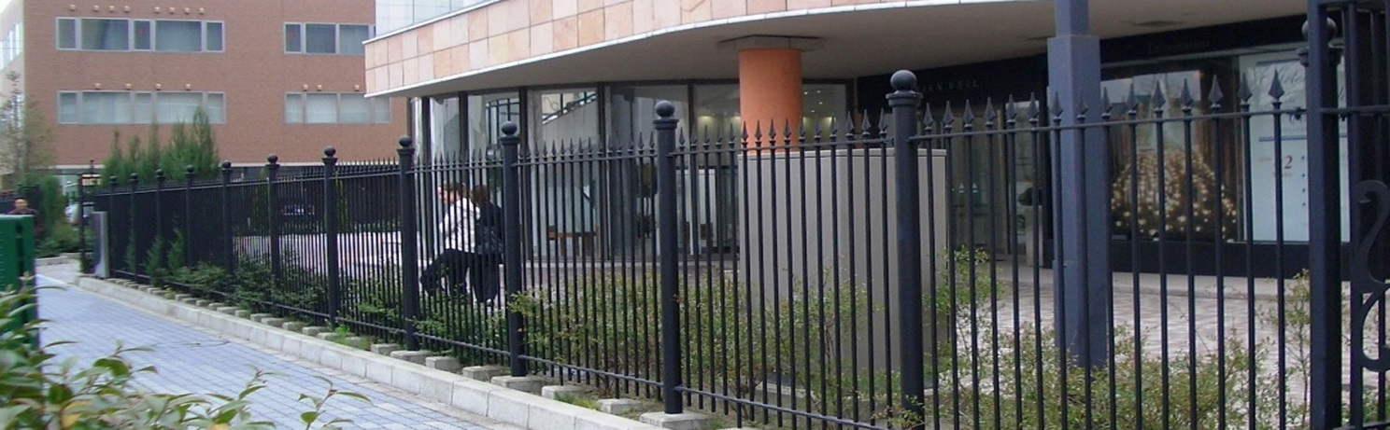

BRUNDLE COATINGS

Welcome to Brundle Coatings. We have extended our range of high quality paints and coatings for both commercial and decorative steelwork to ensure that we can supply exactly what our customers need. Keeping to our usual Brundle ethos of offering exceptional value, we have created a range of excellent products to finish most steelwork paint finishes, many of which are exclusive to F H Brundle. Our range now includes everything from great value commercial red oxides and other primers, though to beautiful decorative finishes for wrought ironwork. We have paints suitable for both internal and external use; for painting directly on to newly-galvanised surfaces; and also our new Anti-Climb Coating, plus our Primers, Solvents, Vinylast™ and Patinas.

We have attempted to have information which is useful to both people who are new to painting ironwork as well as experienced users in this booklet. Feedback and any tips to help us improve are always welcomed.

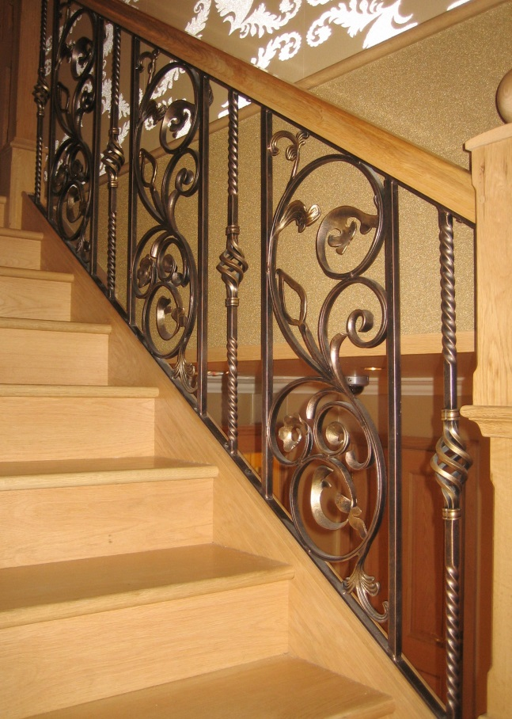Index Page

1 Introduction 2

2 Preparation 2

3 Cold Galvanise Protection 3

4 Primers 3

5 Top Coats 4

6 Patinas and Staygold Paint 8

7 Brundle Anti-climb Coating 10

8 Miscellaneous Products 11

9 Coverage Information 12

10 Thinners & Solvents 14

11 Troubleshooting 14

12 Health & Safety Advice 18

13 Quick Check Charts 19

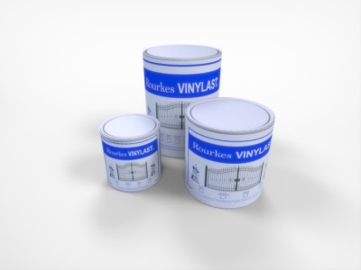

*"We've got you covered..."*

1 introduction

Protecting Steelwork

The first decision most people have to make is how to protect the work you have done. For this we have a choice of red oxide, grey primers and cold zinc galvanise coatings. Each is designed to do the job you want. If the work is external some people may like to hot dip galvanise it before painting, whilst others will prefer a good paint product.

Whichever paints you use, it is advisable to check that the coating has been applied to the correct thickness for the job, either with a low cost wet film thickness gauge (Brundle Product Code: 29PTG01), or an electronic dry film thickness gauge* can also be used. Both will ensure that the correct amount of paint has been applied. With experience it is usually quite possible to simply know what ‘looks’ right simply by judging the appearance and sheen level.

With all paint products, drying times may vary according to temperature, humidity and film thickness. Some coatings may take a considerable time to become fully cured. We also recommend that newly-painted products should always be handled with care.

(\**Please note that electronic dry film thickness gauges may include the thickness of any galvanising and this has to be allowed for. Check before painting and again when the paint has dried. The difference between the readings will be the dry film thickness.)*

To galvanise or not?

Galvanising offers the best possible rust protection, but can be expensive. It will also keep future maintenance to a minimum, and if this is your choice then we recommend that ironwork is hot dipped galvanised to the appropriate British Standard. If you chose to galvanise, then the work must always be allowed to dry *thoroughly* before painting. This can take up to 48 hours, or even more, depending on temperature and humidity. Galvanising is not usually required for internal work.

If you apply paint on top of a galvanised surface this will protect the zinc coating and increase the lifespan considerably as well as providing a decorative finish where required. Some paints, such as Vinyl, may not require pre-treatment.

*For further information about galvanising please visit* [www.galvanizing.org.uk](http://www.galvanizing.org.uk)

2 Preparation

It is extremely important that all work is cleaned off and prepared correctly before painting and highlighting.

For non-galvanised steel, please ensure that the work is dry, clean, free from oil, rust and mill-scale, etc. Our Panelwipe is ideal for cleaning the surface, or for best results, mild steel surfaces could be blast-cleaned or wire brushed thoroughly before painting. This will help adhesion and give a longer life before any maintenance is required.

* Always follow instructions for your products
* Ensure that all surfaces are clean, dry and free from grease and oil
* If you have a glossy surface you may need to abrade or blast-clean
* Always thoroughly mix the paint before using
* Always use the appropriate thinners for your product and use sparingly. Mix well into the paint. Adding too much thinners may mean additional drying time or more coats
* Non-galvanised work will usually require a primer
* Galvanised steel may require a Mordant ‘T’ wash to help adhesion, although our Vinylast™ may not require pre-treatment
* Always use appropriate PPE (personal protective equipment)
* Helpful guides can also be found on our website in the Paint section

If the work is contaminated with oil or grease we recommend F H Brundle Panelwipe/Degreaser. Using Panelwipe will clean the surface and assist adhesion. Panelwipe can be applied with a clean rag or brush. The affected area needs to be wiped clean and left to dry before painting. We have two types of cloths which can be used for application.

*(Preparation cont.)*

Brundle Panelwipe: Product Code: 29PW05

Lint Free Cloth: Product Code: 29SW68 (Approx. 400 cloths)

Low Lint Cloth: Product Code: 29RT150 (Approx. 150 cloths)

For newly-galvanised steel, please ensure that any sharp points have been removed, and that it is thoroughly dry and free from dust, oil or grease before painting. Wiping the work over with our Brundle Panelwipe is an excellent preparation. If the galvanising is very shiny, it may require abrading or a pre-treatment such as Brundle Mordant ‘T’ Wash for best results as this will aid adhesion. Mordant ‘T’ Wash: Product Code: 29MTW05.

Low Lint Cloths

3 COLD GALVANISE PROTECTION

We have a range of high quality cold galvanise coatings, available in both aerosols and brushing paints, for when extra protection is required. Choose below for your solution to repairing and protecting your metalwork. Use our ZG-90 COLD ZINC GALVANISE SPRAY for an excellent anti-corrosion coating, and to repair damaged zinc surfaces. This is also available in a Green or Black finish and our new Brushable version. We also have ZG-90 available in a matt finish for touching up old galvanised steel. Or use our GALVAFROID, which can be used both as a primer and a top coat, to prevent corrosion and rust to provide protection.

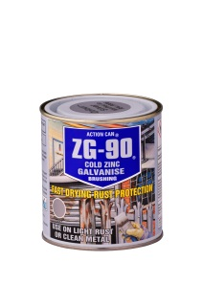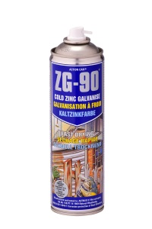

|  |  |  |  |  |
| --- | --- | --- | --- | --- |
| Code | Litres | Colour & Description | Sheen | Thinners |
| 2902A | 0.5 | ZG-90 Bright Cold Zinc Spray | Bright | n/a |
| 2902G | 0.5 | ZG-90 Bright Cold Zinc Spray Green RAL 6005 | Gloss | n/a |
| 2902B | 0.5 | ZG-90 Bright Cold Zinc Spray Black RAL9005 | Gloss | n/a |
| 2902M | 0.5 | ZG-90 Matt Silver Cold Zinc Spray | Matt | n/a |
| 2902ABR | 0.5 | Fast Drying ZG-90 Bright Cold Zinc for Brushing | Bright | n/a |
| 2903 | 0.4 | Galvafroid | Matt | 29002 |

Brushable

Aerosol

**4 PRIMERS**

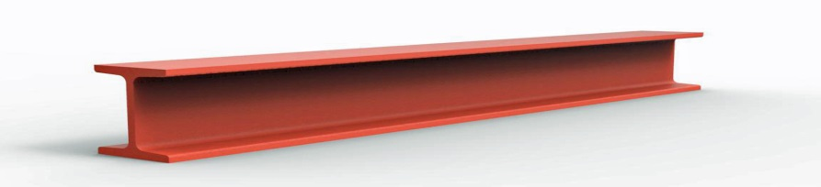

*Right: Red Oxide Primer*

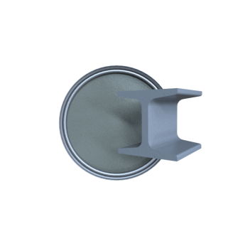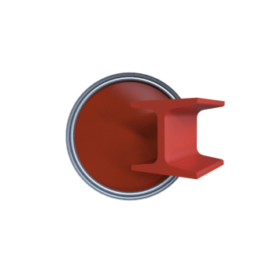Using primers will help protect your steelwork and form a base for your topcoats. Our primers are excellent value, hard-wearing, and are suitable for many coverage applications. Our anti-rust oxide primers can be used on clean or slightly rusted metal, are quick-drying and can be used under most top coat paints. We also have our Brundle Brushable ZP Grey Primer which is designed for priming under our Brundle Brushable Enamels.

|  |  |  |  |  |
| --- | --- | --- | --- | --- |
| Code | Litres | Colour | Sheen | Thinners |
| 2904 | 5 | Red Oxide | n/a | 29002 |
| [290420](http://www.fhbrundle.co.uk/products/290420__20_Litres_Red_Oxide_Paint) | 20 | Red Oxide | n/a | 29002 |
| [2905](http://www.fhbrundle.co.uk/products/2905__2_5_Litres_Red_Oxide_Paint) | 2.5 | Red Oxide | n/a | 29002 |
| [2906](http://www.fhbrundle.co.uk/products/2906__5_Litres_Zinc_Phos_Grey_Oxide_Paint) | 5 | Zinc Phosphate Grey Oxide | n/a | 29002 |
| [2907](http://www.fhbrundle.co.uk/products/2907__2_5_Litres_Grey_Oxide_Paint_Zinc_Phos_low_odour) | 2.5 | Zinc Phosphate Grey Oxide | n/a | 29002 |
| [29010](http://www.fhbrundle.co.uk/products/29010__5_Litres_Black_Satin_Finish_High_Build_Vinyl_Primer_Black) | 5 | Black HBV Primer | Satin | 29002 |
| [2904P](http://www.fhbrundle.co.uk/products/2904P__5_Litres_Fast_Dry_Red_Oxide_Primer_Prime_Quality) | 5 | Fast Dry Prime Red Oxide | n/a | 29002 |
| 29BZPGP05 | 5 | Brushable ZP Grey Primer | n/a | 29WS05 |
| 29ZQDP01 | 1 | Zincaphos QD ZP Grey Primer | n/a | 29002 |
| 29ZQDP025 | 2.5 | Zincaphos QD ZP Grey Primer | n/a | 29002 |
| 29ZQDP05 | 5 | Zincaphos QD ZP Grey Primer | n/a | 29002 |
| 29BRO025 | 2.5 | Brundle Red Oxide HB Primer | n/a | 29002 |
| 29BRO05 | 5 | Brundle Red Oxide HB Primer | n/a | 29002 |
| 29BRO20 | 20 | Brundle Red Oxide HB Primer | n/a | 29002 |

Zinc Phosphate

Grey Oxide

Red Oxide

5 TOP COATS

We have a wide range of excellent top coats for both protection and decoration. We have something in our range for internal and external use, and for painting mild steel or galvanised work. To help you to get the perfect finish for your requirements we will discuss the benefits of each of them in the following sections:

Hi-Build Coatings & Vinylast™

We have a wide range of Vinyl paints which are the perfect paints for decorative and commercial ironwork, such as gates and all types of steel railings. These include our Brundle Vinyl coatings and our Rourke’s Vinylast**™** for that special finish. Vinylast**™** is ideal for using on galvanised steel with the minimum of pre-treatment and will offer a long-lasting and low maintenance finish.

Thinners for Vinyl Paints

For best results when using vinyl based paints we recommend Brundle Product Code: 29002 No.1 Industrial Thinners. This is a high quality xylene based solvent which will help the work to dry faster than standard thinners. When using thinners it is better not to use more than necessary. Too much thinner may lead to an extra coat being required, runs, insufficient film thickness or may lengthening the drying time. Other products may require different thinners and it is important to use the correct thinners with each product. Do not use White Spirit with Hi-Build Vinyl paints.

Brundle Value Vinyl Range

Here we have our range of standard Gloss and Semi Gloss high build vinyl coatings, all with built-in anti-corrosive properties.

|  |  |  |  |  |
| --- | --- | --- | --- | --- |
| Code | Litres | Colour | Sheen | Thinners |
| 29000 | 5 | Black | Gloss | 29002 |
| 29001 | 5 | Black | Semi-gloss | 29002 |
| 29001B | 2.5 | Black | Semi-gloss | 29002 |
| 29006B | 2.5 | Graphite Grey | Semi-gloss | 29002 |
| 29006 | 5 | Graphite Grey | Semi-gloss | 29002 |
| 29015 | 5 | Green BS 4800 14C39 | Semi-gloss | 29002 |

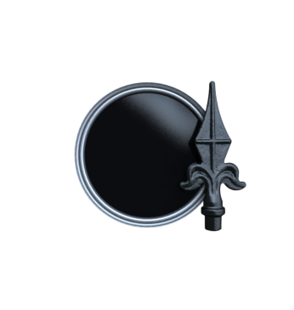

29000 29001, 29001B 29006, 29006B 29015

Rourke’sVINYLAST™ (Use with Product ref.: 29002 No. 1 Industrial Thinners)

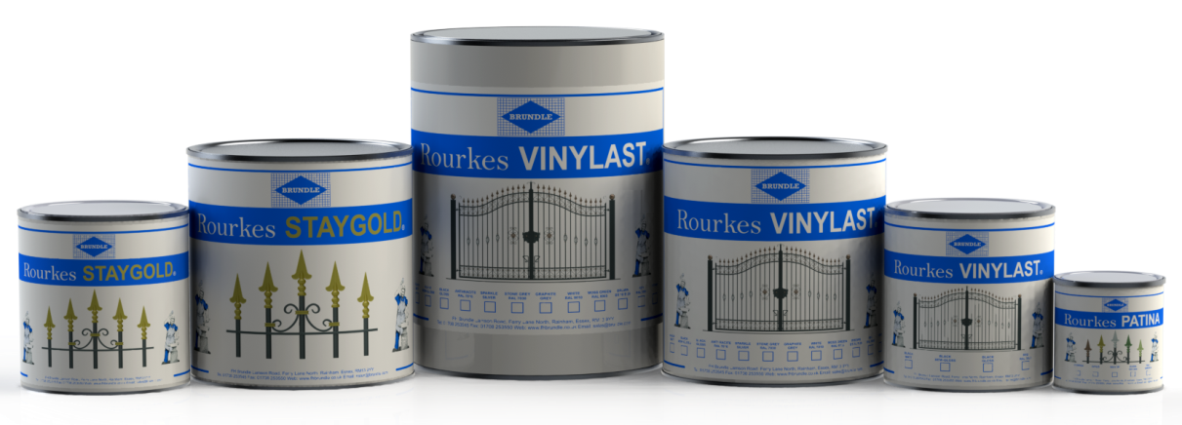

ROURKE’S VINYLAST™

We are pleased to offer the finest quality VINYLAST™ paint which usually* does not need any pre-treatment or primer. Two coats* will give a long-lasting finish on freshly galvanised ironwork and although we recommend that it is best applied by spraying, small areas may be brushed. VINYLAST™ GLOSS is specially formulated to give a glossier finish. It can be applied in the same way, but should only ever be used on top of a matt or semi-gloss first coat.

*\*The finished dry film thickness must be a minimum of 80µ (microns) dry film thickness (d.f.t.) and we recommend 120µ in coastal regions. Depending on the application method, It may require a number of coats to achieve this thickness. If your work is bright and shiny, or you are painting aluminium, then we recommend that you use our ‘T’ Wash, 29MTW05, before painting.*

* Ideal for structural steelwork and decorative ironwork.
* For use on aluminium and very bright shiny galvanised surfaces we recommend pre-treatment with Brundle Mordant ‘T’ Wash (29MTW05).
* Rapid drying, non drip and chip resistant
* Easy to touch up or repaint in the future
* Tough, flexible film, resistant to aqueous chemicals
* Excellent adhesion to freshly hot-dipped galvanised ironwork and also non-galvanised steel
* Cross-cut and impact adhesion far superior to conventional alkyd paints
* Much less long-term maintenance required: only one coat needed when repainting
* Use with our Patina’s to produce beautiful antique and highlighted finishes
* Wide range of colours and sheens available
* Further information and Safety Data Sheets can be found on our website by searching for the product code
* We also have a range of Information Sheets for getting the best from our paints on coatings on our website

**Rourke’s Vinylast™** is a superior product intended for professional users and is designed to enhance and protect decorative ironwork by producing a long-lasting, low maintenance finish that can be highlighted with our Patinas to provide a beautiful appearance. Vinylast™ is intended for the decorative wrought iron market and is produced to adhere directly to galvanised steel usually without the need for mordant solution or etch primers, provided the surface is well prepared and not too shiny, as well as being a high quality and excellent value coating for non-galvanised work. Customers are finding many uses for this high quality product.

With a relatively ‘soft’ coating, Vinylast™ is a perfect product for most decorative ironwork and is a which helps it to be chip resistant, and also makes it easier to repaint with a single coat usually being required and without having to scrape off or wire brush the original coating.

Vinylast™ does not require an undercoat, but it is essential to apply the correct thickness of paint in several coats, depending on the method you use. If you require a special colour, we can produce any RAL or BS colour to order, although a minimum of 5L will usually be required. Please allow a little more time to have non-standard colours made to order. As with all our paints, it is important to follow the instructions to get the best results.

Vinylast™ Colour Range

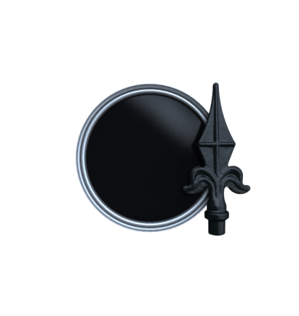Our full range of colours can be seen on our website and in our catalogue. One of our best sellers is semi-gloss Black Vinylast**™**, but many people prefer something other than black!We have a range of colours and can sizes to meet most needs**.** Vinylast**™** Matt and Vinylast**™** Gloss *(only for use as a top coat)* sheens are also available. A firm favourite is Graphite, a modern grey paint with a hint of sparkle, and Anthracite, which are both high quality metallic finishes, with Moss Green, Brown, White and Blue also in demand. We also have Sparkle Silver which will give any metalwork a modern appearance. With the use of our Patinas these colours can offer outstanding finishes that will give many years service and which are popular with customers. They can be over-coated in the future easily and successfully.

Semi-gloss Black Vinylast Product Code: 29RSB05

RAL colour charts can be found at <http://www.ralcolor.com/> and BS colours at <http://www.britishstandardcolour.com> although colours you find online or in a brochure may look slightly different in reality as computer screens and printing inks may vary.

**Vinylast**™**Gloss**

Please note thatVinylast™ Gloss should only ever be used as a **final coat** over the top of a Vinylast™ Matt or Semi-Gloss base. A top coat of Vinylast Gloss™ will give your work a higher sheen level.

Aluminium

For painting Aluminium, please ensure that the surface has been abraded and we recommend that you should always use Brundle Mordant ‘T’ Wash prior to painting with Vinylast™ to aid adhesion.

Application

After suitable preparation, we recommend spraying with Rourke’s Vinylast™ to the appropriate film thickness following the instructions. You will usually require a minimum of 2/3 coats to achieve the required film thickness. We recommend that the first coat is properly applied with at least 40 microns dry film thickness as this will help to achieve a good value, long-lasting, low maintenance and attractive finish to your work.

A good tip is to use a slightly different colour for the first coat if you are spraying, such as Vinylast™ Stone Grey RAL 7030 or any colour of Vinylast™ paint that you may have left over from a previous job. The reason for this is that it is quite difficult to be sure that you have applied two coats and not missed anything if you use black over black. This also makes good economic sense as you can use up any paint left over from a previous job (except Vinylast Gloss).

Some customers like to rig up a gantry so the can get to both sides of the ironwork and then easily move it along so they can paint the next piece. Another method is to lay the work flat on trestles so they can walk around it and get everything from underneath as well, although the piece then has to be turned over to get the other side. If there are a lot of small awkward corners or joints in decorative work, it may be easier to paint these parts with a brush prior to spraying to ensure that you don’t miss any corners which are difficult to spray.

**A few important points for best results when using Vinylast™**:

* Do clean the metal surface prior to painting. We recommend wiping the work down with our Brundle Panelwipe (Product Code: 29PW05) with a **lint free or low lint cloth** (Product Codes: 29SW68 and 29RT150).
* Rourke’s Vinylast™ is self-priming. It only requires the correct film thickness being applied. Never apply over conventional primers or other paints without testing compatibility first.
* Always apply at the correct film thickness – and use a wet film thickness comb (Product Code: 29PTG01)to check the thickness. Insufficient film thickness can increase maintenance requirements.
* The first coat should be about 40 microns d.f.t. If it is too thin it may impair adhesion.
* Vinylast™ Gloss should only ever be used as a **final coat** on top of coat(s) of Matt or Semi-Gloss Vinylast™.
* For best results always use Brundle No.1 QD Thinner: Product Code: 29002(5L). Never use more thinner than needed,
* Please note that the xylene solvents used in Vinylast™*may* react with items like some types of electrical cables or plastics such as bubble wrap, and therefore we always recommend testing samples if used next to rubber or plastic materials. If Vinylast™is to be used on light fittings and may come into contact with cables, a barrier of clear varnish MUST always be used.
* Never use our Brushable ZP Grey Primer (Product Code: 29BZP025) as a primer for Rourke’s Vinylast™. The White Spirit base is not compatible. This primer is for use with our Brushable Enamels only.
* Please check our other Advice Sheets for further information.

Always prepare the surface correctly:

* All surfaces must be dry, sound and free from dirt, dust, rust and grease. (See above.)
* Non-galvanised mild steel surfaces should be blast cleaned or thoroughly wire brushed prior to painting for best results.

Galvanised steel:

* Dull or matt galvanised steel will give the best results
* All work must be clean and thoroughly dry before painting. For best results use Brundle Panelwipe (Product Code: 29PW05) applied with a lint free cloth (Product Code: 29SW68).
* For previously weathered galvanised steel if there is any ‘white rust’, or zinc corrosion deposits which appear as a pale grey powder, wash with copious quantities of water to remove. Allow to dry thoroughly.
* Galvanised steel which has been contaminated with oil or grease should be thoroughly cleaned to remove all traces prior to coating. For best results use Brundle Panelwipe (Product Code: 29PW05) applied with a lint free cloth (Product Code: 29SW68).
* Chromated galvanised steel should be alkali cleaned to remove the chromate passivation.
* Bright spangled galvanised steel will often require preparing with our Brundle Mordant ‘T’ wash (Product Code: 29MTW05) or thoroughly abrading using P600 wet or dry abrasive paper (or similar) before painting.

Aluminium:

Treat with our Brundle Mordant Solution (Product Code: 29MTW05),or abrade lightly using P600 wet or dry abrasive paper (or similar) or before painting to help adhesion.

Application: Always apply correctly following instructions for best results

**Film thickness**: Ensure the minimum total film thickness is 80 microns dry and 200 microns wet.

For coastal or severe environments we recommend that you should increase the film thickness to 120 microns (µm) dry and 300 microns wet, to ensure white zinc salts do not migrate through the coating to the surface.

Airless sprayUp to 5% thinners may be added to suit equipment.

Apply one or two heavy coats.

Typical tip size 13-19 thou.

Typical fluid pressure 200 kg/sq. metre or 2800 p.s.i.

Conventional sprayThin up to 10% with Brundle 29002 Thinner, less is better.

Apply 2-3 coats to achieve the recommended 80 microns d.f.t. (dry film thickness)

Brush/Roller Apply 3 to 4 coats evenly using a well-loaded brush.

Allow to dry between coats. Do not attempt to brush out or lay off.

Thinners For best results when painting Vinylast™ use our Brundle No.1 QD Thinner: Product Code: 29002

*Mechanical and electronic dry film thickness testers for paint are available from Elcometer (T: 0161 371 6000).

*Inexpensive plastic wet film thickness combs are available from F H Brundle. Product Code: 2929PTG

Future Maintenance of Vinylast**™**

One big advantage of using Rourke’s Vinylast™is that it is long-lasting and very low maintenance when applied to the correct film thickness. It will look good for many years and then it is very simple to repaint in the future. Just ensure that the work is clean and dry before repainting with your chosen colour. It can also be easily highlighted using Patinas and a piece of sponge. (See Chapter 5.) Work that has been powder coated can be very difficult to recoat or to change the colour in the future.

Useful Tips:

* Any colour Vinylast™ (except gloss finish) can be used as a first coat with your required finish as the final coat. This avoids any half used cans and can save money. This works best when a spray is used.
* If a different colour first coat is applied (E.G. Dark Grey under Black) it is much easier to see what has been sprayed the first time and ensures that an even coat is applied and helping to maintain film thickness.

ENAMEL FINISH

For those who prefer enamel finishes we have a range to meet all requirements. Generally the finished surface is harder and will stand up to mechanical abrasion better than vinyl-based paints, which can be useful for some types of work such as handrails, seating or furniture. Enamels are suitable for both internal and external ironwork. F H Brundle offers two distinct types of enamel finishes for brushing or spraying. We have Brundle Brushable Enamel and Rourke’s Enamelrite. Please note that both these products use different solvents and have different application methods so hopefully we can provide a perfect solution for your requirements. We also offer our 29001P which is high quality semi-gloss enamel in Black RAL 9005. It is important use the correct thinners for each product at all times.

Prime Black Enamel

A top quality general purpose Black Semi-Gloss Enamel.

|  |  |  |  |  |
| --- | --- | --- | --- | --- |
| Code | Litres | Colour | Sheen | Thinners |
| 29001P | 5 | Prime Black Enamel RAL 9005 | Semi-Gloss | 29002 |

Brundle Brushable Enamel (Thinners: Product ref.: 29WS05)

The perfect solution for brush painting indoor ironwork. Brundle Brushable is excellent for painting smaller areas by brush and is also better for items like light fittings where the solvents are less likely to have a reaction with materials like cables, plastics or rubber which they may come into contact with. We offer a choice of satin or gloss sheens. Many customers like a satin finish with patina highlights, and for this our Brundle Brushable Enamel is the perfect choice. Available in Black RAL 9005 or White RAL 9010 in 2.5L cans. Use with our White Spirt thinners as necessary. Please note Brushable Enamel should not be used on the top of any xylene based products.

Application

1 Primer Brushable Zinc Phosphate Grey Primer (29BZP05)

2 Top Coat(s) Brundle Brushable Enamel

3 Thinners Brundle White Spirit, 29WS05

4 Highlight with: Rourke’s Patinas or Rourke’s Staygold

Rourke’s Enamelrite(Thinners: Product ref.: 29002 QD Thinners)

If you prefer to spray, then Enamelrite is a good quality enamel for both internal and external use. Enamelrite is available in both gloss and satin sheen levels, and in both Black and White RAL 9010 in 5L cans.

Application

1 Primer Zincaphos QD ZP Grey Primer 29ZQDP05 (5L)

2 Top Coat(s) Rourke’s Enamelrite - Sprayable Enamel

3 Thinners Brundle 29002 QD Thinners

4 Highlight with: Rourke’s Patinas or Rourke’s Staygold

HAMMERED FINISH (Use 29002 Thinners)

Our Hammered Finish paints are suitable for hiding uneven surfaces and imperfections and still producing an attractive finish. We have Black in 1L and 5L cans, and Silver Grey in 5L cans. Always remove any loose material and wire brush before use if painting rusty ironwork.

METALLIC FINISH

Our metallic paints are high quality, quick-drying liquid metal paints that offer a rich sheen finish and provide a unique and classical decorative coating. The product is suitable for both internal and external use on many substrates and provides a luxurious finish to your work. We have our standard gold paint as well as our high quality Staygold, which will keep its colour long after many other paints fade. These are specially designed to paint railheads and other details to give a solid gold-coloured appearance. Sparkle Silver, one of our Vinylast range is a general finish which will give a very modern look to most ironwork.

Gold Product code: 29014 (Use 29WS05 Thinners)

Rourke’s Staygold Product code: 2907 (Use 29WS05 Thinners)

Rourke’s Sparkle Silver Vinylast™ Product code:29RSS025 (Use 29002 Thinners)

6 Patinas and Staygold Paint

A quick and easy way to add value to your work, these products can also be applied after painting the ironwork with Rourke’s Vinylast™ or other top coats. When highlighting, we recommend applying Patina to a small test area first to ensure the appropriate finish is obtained. Some of your customers may like the patinas to be very subtle whilst others like a lot more colour, so we would recommend that you start with a light layer of patina and build up as necessary. If you have examples to show your customers it gives them a choice and most enjoy having a personalised touch to their new work. Remember that it is far easier to add more Patina than it is to remove it! Staygold is perfect for painting railheads and details to give a solid gold appearance, and will last outdoors much longer than many other alternative gold paints.

Staygold

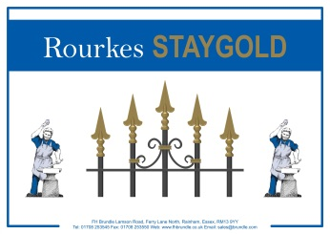For parts which require a solid gold colour, we recommend using Rourke’s Staygold – this is an exceptionally high quality paint for smaller areas which are required to be gold, such as railheads and other features. Staygold stays bright much longer than many other gold paints - it does what it says, and stays gold for longer! Staygold would normally be brushed on top of the sprayed ironwork and need at least two coats for best results.

**Staygold 1L: Product Code: 29007**

Designed to last

**Thinners for Staygold:** **Product Code:** **29WS05** (5L)

Rourke’s Patina

Used for highlighting, Rourke’s Patina’s are high quality products which were developed to enhance the appearance of decorative wrought ironwork quickly and easily without adding significantly to the cost. Choose the perfect colour from our patina paint range to give your wrought-iron that aged iron and worn look. For only a small amount of time and expense, using patina will enhance your work to give a beautiful appearance. Rourke’s Patinas are tried and tested quality patinas, which will out–perform most alternatives. Best applied by sponge, they are formulated to keep their colour for many years. They are also used to provide a range of modern finishes, offering customers a wider choice of colours to match their house or interior. Patina finishes are popular with clients and will make your work stand out from the rest. They will create a luxury feel to your work, simply by spending a few minutes time and using a tiny amount of paint.

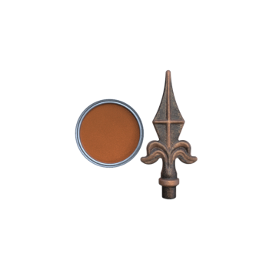 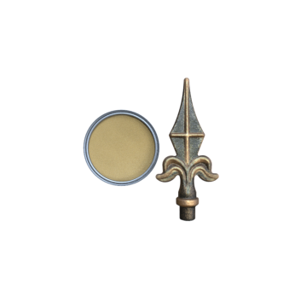 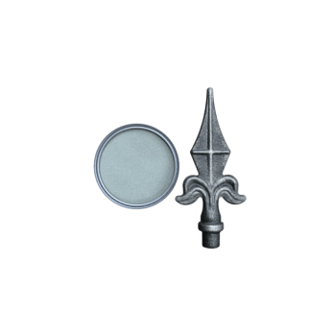 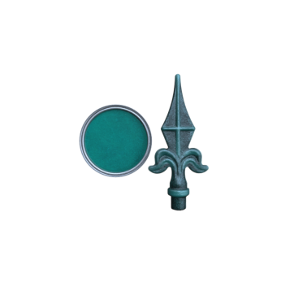

Copper Gold Silver Verdigris (green)

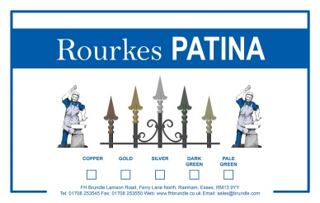Patina Product Codes (375ml):

Copper/Bronze Patina: 29P001

Gold Patina: 29P002

Silver Patina: 29P003

Verdigris (Dark Green) Patina: 29P004

Highlighting Sponge for Application 29FOAM

White Spirit Thinners for Patinas 29WS05

The original Rourke's Patina

* Available in 375 ml of Patina supplied in a 500ml can

*Tip…* Try mixing colours together, or applying one on top of another to create your own special effects!

*N.B. Gloss finishes may not highlight as satisfactorily with Patinas as will Matt or Semi-Matt sheens.*

Application

Rourke’s Patinasshould be carefully applied after painting your work, remembering that is easier to apply a little more but impossible to take some off without painting over and trying again. You will find that with a little practice it is very easy to highlight. There are different methods of applying patinas and after a little practice you will decide which you prefer. Some people like to use an almost dry brush, which has a very small amount of patina on it and lightly drag this along the work to be highlighted, however others prefer the sponge method or even an air brush.

Application by sponge:

* The sponge we prefer is of a dense nature, similar to sponge used for upholstery. Product 29FOAM is available from F H Brundle.
* Always stir the patina well before applying and seal cans after use

The patina needs to be of a slightly thick nature and initially it is better not to add thinners. However if the patina has been used a few times and has thickened with the evaporation of the solvents, then a small amount of thinners can be added. It is better to try only a very small amount and stir well, before adding more if necessary. Thinners: White Spirit (Product Code: 29WS05)

* Pour a small amount of patina onto a piece of cardboard (minimum suggested size 300mm x 300mm)
* Dip the sponge into the patina, wiping any excess patina from the sponge onto the cardboard. Only a small amount of patina should be on the sponge. Too much, and a streaking effect will be the result.
* Try lightly applying to a small area until you are happy with the result. You can easily add more colour if you wish to build it up to the desired appearance.
* Wipe the sponge lightly onto the section of ironwork which is to be highlighted and repeat as often as necessary to achieve the effect you desire. This will pick out and enhance all the details.
* Discard, or trim down, the sponge when it becomes unusable.
* With a small amount of practice you will soon master the art of highlighting and soon be producing beautiful finishes on your work.
* After use make sure that you fit the lid correctly to prevent evaporation of the solvent.

7 BRUNDLE ANTI-CLIMB COATING

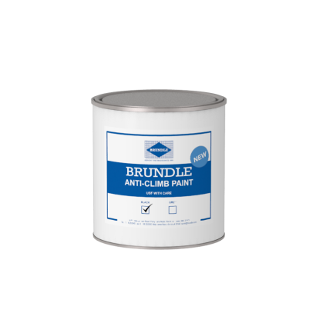We have added these security coatings to our range. Please note that Health and Safety recommendations should be read for these products and appropriate PPE should be worn. We have our Advice Sheet No. 8 available for further information on our website.

|  |  |  |  |  |
| --- | --- | --- | --- | --- |
| Code | Litres | Colour & Description | Sheen | Thinners |
| 29ACCB01 | 1 | Brushable Black Anti-Climb Coating | Gloss | Not Req. |
| 29ACCG01 | 1 | Brushable Grey Anti-Climb Coating | Gloss | Not Req. |

*Other sizes may be available on request.*

Anti-climb coatings are intended for industrial users who wish to add security to a property and can also be described as anti-vandal paint or grease, anti-intruder coating, or sometimes non-drying paint. They provide a thick glutinous coating, which remains greasy, or oily, after application, however it *looks* similar to gloss paint in appearance. Brundle Anti-Climb coating will remain slippery and the object is to deter and prevent intruders for climbing or gaining a foothold.

Coverage is approximately 2.5m. sq. per litre by brush

Usage

Brundle Anti-Climb Coating is often used for painting walls, lamp-posts, drainpipes, roofs or fences and is there to act as a deterrent. Although appropriate care must always be taken in the location of the Anti-Climb coating, it can be an excellent deterrent and may prevent an intruder from breaking in. An intruder is also a lot more likely to come to the attention of the police if their hands and clothes are covered with signs of the attempted break-in!

Health & Safety

412[1] **Please take all necessary H & S precautions and use as only as instructed.** It is important to wear appropriate protective clothing (PPE) and to prevent any Brundle Anti-Climb Coating from getting on your clothes or coming into contact with skin as it is designed to be difficult to remove. Although not usually harmful, it WILL stain clothes and the skin of anyone who comes into contact with it. Brundle Anti-Climb coating is designed to deter people from coming into contact with it.

Health & Safety Data Sheets can be found on our website at [www.fhbrundle.co.uk](http://www.fhbrundle.co.uk) by searching for the Product Code and clicking on the SDS button. MSDS are also available from any of our branches in person or by telephone or e-mail request. You can also request a copy by calling +44 (0)1282 834545 between 08:30 and 16:30, Monday to Friday. We will be happy to e-mail or post a copy to you.

* Typically Anti-Climb coating is used only above 2.4 meters high and Warning signs* should be used as required.
* The user is responsible for checking that the use applies with legislation and any regulations.

Application You can apply with a stiff brush, trowel or by hand using a protective glove. Do not apply too thick a coat as it may run down a drainpipe or wall. Take care not to let it contact your clothing or skin.

Thinners We do not recommend using thinners with this product.

Cleaning brushes We recommend our Brundle White Spirit, Product Code: 29WS05

Typical Lifetime of the Anti-Climb Coating

Anti-climb coating has an effective lifetime of around 3 years, after which another coat may be required if necessary.

Legal Issues

The Occupier’s Liability Act 1984 says that householders have a duty of care to anyone on their property, whether or not they are entitled to be there.

The Highways act 1980 states that care must be taken to avoid “harm or injury” to any person or animal using the highway.

If you have any doubts about using Anti-Climb coating, we recommend consulting the appropriate authority. You may also wish to consult the local Crime Prevention Officer for advice.

To discharge the Duty of Care owed to trespassers, the householder must put up a warning sign*, or signs, if they are using Anti-Climb paint. These signs are inexpensive to purchase. Anti-Climb coating is also recommended only for use at a height of over 2.4 metres.

412[1] *\*Anti-Climb Paint Warning signs are available to purchase from several on-line stores.*

Tips

* Always be aware that cats like to walk along the tops of walls and the client may not be happy with a set of greasy paw prints on their new cream carpet! It’s always best to carefully consider the location before applying Anti-Climb coating.
* Think about the ease of access to the property if maintenance is required.

Please Note -To place an order, you can find a list of all our depots and contact numbers on our website at [www.fhbrundle.co.uk](http://www.fhbrundle.co.uk) and you are also welcome to e-mail [sales@brundle.com](mailto:sales@brundle.com) for prompt attention.

8 MISCELLANEOUS PRODUCTS

AEROSOL SPRAY CANS

We have an excellent selection of aerosol sprays for touching up scratches as well as our HT-90 Black High Temperature paint and our Red Oxide Aerosols. Our Vinylast™ Aerosols match the Vinylast™ paints and are ideal for touching up small areas on site. Many colours could be made to order in batches of 6 cans.

|  |  |  |  |  |
| --- | --- | --- | --- | --- |
| Code | Litres | Colour & Description | Sheen | Thinners |
| 2909 | 0.5 | HT-90 Black High Temperature Aerosol | Matt | n/a |
| 2904A | 05 | RX-90 Red Oxide Primer Aerosol | Semi-Gloss | n/a |
| [29RMBS](http://www.fhbrundle.co.uk/products/29RMBS__Matt_Black_Paint_400_ml_Spray_Rourkes_Vinylast) | 0.4 | Rourke's Smithy Black Vinylast™ Aerosol | Matt | n/a |
| [29RGBS](http://www.fhbrundle.co.uk/products/29RGBS__Gloss_Black_Paint_400_ml_Spray_Rourkes_Vinylast) | 0.4 | Rourke's Smithy Black Vinylast™ Aerosol | Gloss | n/a |
| 29RSBS | 0.4 | Rourke's Smithy Black Vinylast™ Aerosol | Semi-Gloss | n/a |

PAINTS TO MATCH POWDER COATING

Ideal for touching up scratches and any damage to powder coated products, with a choice of brushing or aerosol cans.

|  |  |  |  |  |
| --- | --- | --- | --- | --- |
| Code | Litres | Colour & Description | Sheen | Thinners |
| 29PC1BG | 1 | Brushable Green RAL 6005 | Gloss | n/a |
| 29PC1BB | 1 | Brushable Black RAL 9005 | Gloss | n/a |
| 29PC400SG | 0.4 | Aerosol Spray Green RAL 6006 | Gloss | n/a |
| 29PC400SB | 0.4 | Aerosol Spray Black RAL 9005 | Gloss | n/a |

.

PAINT ACCESSORIES

To complement our range of paints we have added these useful accessories. The first are our Wet Film Thickness Gauges which are used to check how much paint has been applied. We also have a choice of cloths for cleaning off work, spray equipment and many other uses around your workshop. Our Low Lint Textile cloths come in a pack of approx. 150 pieces, whilst out Non-Woven Lint Free Cloths come in packs of 400 pieces.

|  |  |  |  |  |
| --- | --- | --- | --- | --- |
| Code | Pieces | Colour & Description | Sheen | Thinners |
| 29RT150 | ~ 150 | Pack of Low Lint Textile Cloths | n/a | n/a |
| 29SW68 | ~ 400 | Box of Non-Woven Lint Free Cloths | n/a | n/a |
| 29PTG01 | 1 | Wet film thickness combs | n/a | n/a |

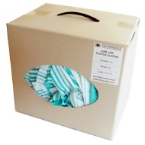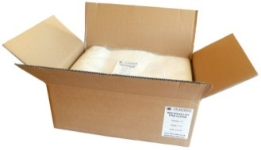

29RT150

29SW68

Wet film thickness combs

**9 COVERAGE INFORMATION**

Introduction

One question we are often asked is, *“How much paint will I need to paint (x) metres of railings?”*

There isn’t an easy answer because so many different factors come into play. Many paint manufacturers will offer a *‘theoretical coverage’* as a guide; however *practical coverage* is usually only a percentage of this figure. In our case we are offering advice to people who will be usually be painting ironwork. Even so, the work you are painting may vary considerably from one project to the next. It could be a simple hooped bar railing or it could be a very heavy, highly decorative pair of gates, with heavy duty posts. The latter will obviously use far more paint per metre than the simple hooped railings. Painting RSJs with a brush would get much closer to the theoretical coverage. There are many other factors which affect coverage so we will attempt to provide you with some information which may be useful.

\\File\tsdesktop\rt1\Desktop\light-bulb-and-a-star-15838-large[1].png We suggest that you record how much paint you have used to paint a particular job. You can then work out how many square metres you have painted and this will give you a litres per square metre figure. If you do this with a few of your jobs you will soon get a good idea of how much paint you are using for each style of work that you do and how much you need to order and allow for when you are next preparing a quote.

**Rourke’s VINYLAST™**

**Theoretical coverage**

For Vinylast™, the theoretical coverage is 4 sq. metres/litre at 235µ (microns) wet film thickness. The spreading rate of this product may vary considerably depending upon the method of application and the roughness and porosity of the surface. In practice, this figure may be reduced by up to 40%.Theoretical coverage is obtained by applying the paint onto a flat surface in ideal conditions. With a skilled operative the paint should cover one side of a 4 sq. metre surface to the given thickness.

Practical coverage

In practice, painting ironwork is different. There are spaces between the bars and the ironwork needspainting on all sides and not just on one flat surface. Plain work will need less paint than very decorative work. Conditions, methods of application and equipment will all affect the theoretical coverage. The figures given below are what have been found, from experience, when painting typical ironwork. These figures are intended as a helpful **GUIDE ONLY** and we cannot accept responsibility for any variations you may find.

The following figures were obtained by a skilled sprayer, in a spray booth, and gave a dry film thickness (d.f.t.) of approximately 40 microns d.f.t. Please remember that:

* More than one coat is often necessary to achieve the minimum recommended d.f.t .of 80 microns
* In coastal areas we would recommend 120 microns d.f.t. and some customers would require it.
* Some local authorities will ask for 120 microns d.f.t.
* To achieve 120 microns d.f.t. you probably need to apply more than 2 coats. This depends upon your equipment and the skill level of the operator and how much thinners have been used.
* We recommend using a contrasting colour (such as dark grey under black) for the first coat to make it easier to see what you have already painted and to ensure that the whole of the work is covered with the following coat. This also has the advantage of always being able to use up any paint of a different colour left over from a previous job.
* Check the film thickness of the paint with a film thickness gauge. Details can be found on page 11.
* The symbol for microns is µ.

The figures below are an approximate guide for painting BOTH sides of the ironwork with Vinylast™:

BRUSH:250ml per square metre per 40 microns (μm) d.f.t. coat

CONVENTIONAL SPRAY:Using a 1.8mm nozzle on a gravity feed gun, 750ml of Vinylast™ was used per sq. metre at per 40 micron d.f.t.

ELECTROSTATIC SPRAY:With electrostatic equipment, 430ml of Vinylast™ was used per sq. metre, per 40 micron d.f.t. coat.

ROLLER:We have no figures available at present, but would expect a similar figure to brushing.

THINNERS:For best results use Rourke’s QD Thinners **Product Code: 29QDT05 (5L)**

AEROSOLS:Although Aerosols are mainly used for touching up on site or painting small items, the theoretical coverage is 2.32 sq. metres at 10 microns d.f.t.

CONVERT WET AND DRY FILM THICKNESS:

Should you need to convert wet and dry film thickness you can do this with the following formulae. You need to know the percentage of solids in the paint.

WFT = Wet film thickness = ‘W’

DFT = Dry film thickness = ‘D’

Percentage of solids in the paint = ‘P’ (By volume)

Percentage of Added Thinners = ‘T’ (By volume)

No Added Thinners

W = D D = W x P P = D_

P W

With Added Thinners

D

W = _ P___ D = W x P x (1 + T) P = D x _1__

(1 + R) W (1 + T)

To obtain a dry film thickness of 81 microns using Vinylast™ it will require a total of approx. 300 microns dry film thickness.

Other Brundle Paint Products

The theoretical coverage rates for our other paints are as follows:

* Rourke’s Enamelrite 10.7m2 per litre at 30 microns dry film thickness (d.f.t.)
* Brundle Brushable Enamel 10.7m2 per litre at 30 microns dry film thickness (d.f.t.)
* Brundle Value Vinyl 5.3m2 per litre at 75 microns d.f.t.
* Brundle Anti-climb Coating Approx. 2m2 per litre
* Primers, typically Approx. 18.7m2 per litre at 30 microns d.f.t.

In practice these figures may well be reduced depending on equipment and application.

10 THINNERS & SOLVENTS

We have two different types of Thinners (or solvents) which can be used with our products. For best results we recommend that you add the least amount of thinners that is necessary when thinning your paint. Adding too much can mean the paint taking longer to dry or may mean that an additional coat is necessary.

* Always mix into the paint thoroughly.
* It is essential that the correct type of solvent is used for the paint you are using. Using the wrong type of solvent may cause problems.

|  |  |  |  |  |
| --- | --- | --- | --- | --- |
| **Product** | **Product Code** | **Can Sizes** | **Use with Coating** | **Notes** |
| FHB White Spirit | 29WS05  29WS25 | 5L  25L | Rourke’s Patinas  Rourke’s Staygold  Brundle Brushable Enamel  Brundle Brushable ZP Grey Primer | Essential for these products |
| Brundle No.1 Industrial  QD Thinners | 29002  2900225 | 5L  25L | Brundle Red Oxide  Brundle Grey Primer  Brundle Value Vinyl  Rourke's Enamelrite  Zincaphos QD ZP Primer  Rourke’s Vinylast™ | Excellent value and quick drying. |

OTHER SOLVENTS AND ACCESSORIES

|  |  |  |  |  |  |
| --- | --- | --- | --- | --- | --- |
| **Product Code** | **Can Sizes** | **Product** | **Apply by:** | **Use for** | **Notes** |
| 29MTW05 | 5L | Brundle Mordant ‘T’ Wash | Brush | Pre-treatment of aluminium or bright, spangled galvanised surfaces | Always use PPE when applying. |
| 29PW05 | 5L | Brundle Panelwipe | Brush | Use for cleaning and degreasing work before painting |  |
| Cloth |
| 29SW68 | 400* cloths | Lint Free Cloth | n/a | For use with Brundle Panelwipe and general purposes | Great value |
| 29RT150 | 150* cloths | Low Lint cloth | n/a | General purpose cloths |  |
| 29GW05 | 5L | Brundle Gunwash | n/a | Use for cleaning spray equipment |  |
| 29GW25 | 25L |
| 29FOAM | n/a | Foam pieces | n/a | Highlighting with Rourke’s Patinas | Applying Patina with Foam sponges will give the best results. |

**11 TROUBLESHOOTING & PREVENTING PROBLEMS**

This section contains useful information and it may help to avoid any likelihood of problems if read before starting painting your work. It was written for Rourke’s Vinylast™ and may also be useful with other paint products.

Rourke’s Vinylast™ is a high quality, low maintenance finish specially designed for painting decorative ironwork. Since Vinylast™ was developed in 1990, it has been used on decorative ironwork in the UK, and around the world, with very few problems. However should you experience anything but total satisfaction, here is a guide to what may have occurred, possible solutions and how to avoid potential problems the future.

Generally to avoid problems, just follow the paint instructions. Clean off any sharp or unsightly areas on newly galvanised work. All work must always be clean and dry, and free from dust, oil, or grease before paint is applied and you must always apply paint to the recommended dry film thickness (d.f.t.). We recommend a minimum d.f.t. of 80 microns (µm), and up to 125 microns in adverse locations. Always use the correct thinners and apply the correct amount. Please read our other Advice Sheets for detailed information on preparation.

** In the unlikely event that you have a problem, please make a note of the batch number found on the can and the date it was purchased and contact one of our helpful sales staff. The batch number will be required to allow the product to be traced and checked against the sample which is taken from every batch that is made. Information such as the type of thinners used, how much the paint was thinned down, how the work was painted, if the work galvanised and any photos of the work are invaluable in solving any problems. The more information we get the better we can advise you.**

For best results make sure that all work is completely dry before painting. Keeping a reasonable temperature in the spray area is also important, but ***always*** avoid having any naked flames in any area where paint is being applied. We also recommend leaving the work a minimum of 2-3 days after painting before installing it, and recommend you to avoid any heavy handling before the paint has fully cured, which can take some time depending on the temperature and the film thickness. Careful handling during transportation and installation of the work can save you time on site in touching up scratches and damaged paintwork.

Storage and Application Temperatures

Ideally paint should be stored between 5°C and 28°C and never below 0°C. Application temperature should be between 12°C and 22°C if possible. Please note that very low or high temperature can cause viscosity variations which can affect results.

Possible problems and solutions

a) Small bubbles or blisters appear on the surface of newly painted work

The most likely cause is moisture on the galvanised work. Trapped moisture tries to evaporate and causes small blisters to appear.

**Solution:**

* If this occursyou can try letting the paint thoroughly dry and then lightly abrade the surface and apply another light coat, otherwise you may need to strip off the paint and leave it to dry for 48 hours before repainting.

**Prevention:**

* Always ensure that work is thoroughly dry before painting. Although galvanised ironwork may feel dry to touch, moisture can be trapped in corners where scrolls or bars are welded. Often people are in rush to get the job done and spray the work as soon as it arrives from the galvanisers but unfortunately it will take even longer if the work is not completely dry. Remember that your work may have been in a bath of water when it came out of the galvanising tank, or it may have rained on the journey back to you from the galvanisers. In an unheated workshop in winter it can easily take up to 48 hours or longer to dry properly.

b) Paint is flaking

This is usually an adhesion problem. If the film thickness is checked and the correct film thickness has been applied then several things must be considered:

* This is commonly caused by insufficient paint being applied, especially on the first coat.
* Was the work a very shiny galvanised finish?
* Was the work sufficiently dry before coating?
* Had it been properly prepared and any contaminants cleaned off?
* The coating may not have been given enough time to thoroughly dry and fully harden (see Section 5 below).
* Adding too much thinner can contribute to adhesion problems.
* Has the correct thinners been used?

Solutions:

* In many cases additional paint will cure the problem. We suggest adding at least one more thick coat to a small section and checking the results. Please check the film thickness with a mechanical or electronic gauge and if this is the case additional coats may be required to obtain the recommended dry film thickness of between 80 – 120 µm (microns). Please see Advice Sheet 2 - Coverage Information.
* The alternative is to strip the paint and start again.

Prevention:

* Always prepare well before painting - clean off all dirt, millscale, weld spatter, oil and grease, etc. Any oil or grease can be removed with **Brundle Panel Wipe (**Degreaser) Product Code: 29PW05**,** prior to painting.
* Very bright shiny metal surfaces must either be lightly abraded or treated with **Brundle Mordant Solution (Product Code: 29MTW05)** to achieve better adhesion.
* Mild steel could be prepared by grit-blasting followed by painting as quickly as possible
* Do not use too much thinner. Ideally with Vinylast™ the minimum necessary amount of thinners should be used. Always use the recommended thinners for Vinylast™ which is Product Code: 29002 No. 1 Industrial QD Thinners. Other products may require our 29WS05 White Spirit. Always check if you are unsure. See Paint Advice Sheet No. 10.

c) Rust has developed

If the work was not hot dip galvanised, either the metal was already rusty and this was not fully removed, or the paint coating is too thin. If the work is galvanised, one other problem which can occur is if customers call after a few weeks and say that the work is rusting. They will say that there are a lot of spots which have gone rusty. This can happen if an installer has accidentally cut or ground some steel with an angle grinder close to the painted surface. The result is that you get tiny specks of rust on the surface which has been caused by the hot sparks of metal embedding themselves into the surface of the paint. It can appear as if rust is coming through the paint, but this is not the case, and the simple solution is to paint over this area and cover the tiny pieces of metal.

Solution:

* It all depends on the severity of the rust. In severe case the surface may need full preparation with the rust being removed. Work that is severely rusty may require blast-cleaning before painting. If you do blast-clean, then please paint as soon as possible after this process.The recommended minimum film thickness is 200 microns wet and 80 microns dry. However for coastal environments this must be increased to 125 microns dry film thickness (d.f.t.) for the best results. Always make sure that the surface is clean, dry, and free from rust before painting.
* Repaint, ensuring that sufficient paint is applied and making sure that paint gets into corners and crevices.

Prevention:

* One suggestion to help achieve the required film thickness is to use a different colour as a first coat. We usually suggest a first coat of dark grey and followed with black to ensure that the sprayer covers every part at least twice to help obtain the correct minimum film thickness. Black on black is hard to see and therefore it is difficult to assess the coverage correctly. You can also use most colours as a base for most colours of topcoat, which enables any surplus or redundant stock to be used up easily, so there is never a need to have any waste material with Vinylast™. With experience it is possible to judge the appropriate thickness quite well.
* Many times this problem can be traced back to thinning the paint excessively. Please note that for a conventional sprayer no more than 10% thinner should be used if possible and if more is needed consider buying a new spray unit.
* To ensure that the correct film thickness is applied a film thickness gauge (29PTG01) should always be used. These are available in mechanical and electronic versions for use on dry product or simple, inexpensive wet film thickness combs can be used. These can be plastic or slightly more expensive metal combs. A quick rule of thumb is that the wet film thickness is about 2.5 to 3 times the dry film thickness (d.f.t.).The difference between wet and dry film thickness is due to solvents evaporating during the drying process.
* Never cut or grind steel near painted work. Sparks can embed themselves in the paint surface and rust. This makes the work look rusty although it is perfectly sound underneath.

d) The paint is peeling off a galvanised surface

This may be an adhesion problem, but could also be caused by applying FAR too much paint in a single coat.

Solution:

* The paint may still be soft, so it could be worth allowing more drying time.
* Usually the only solution is to strip the paint, and start again, with good preparation and applying coats as recommended.

Prevention:

* All surfaces must be clean and oil free before painting. Please see Advice Sheet 1 on how to prepare the work for painting.
* Peeling can alsobe caused by applying FAR too much paint.
* If the galvanised surface is bright and shiny apply Brundle Mordant ‘T’ Wash (Product Code: 29MTW05)before painting.
* Bright shiny galvanising could also be abraded first before painting with Vinylast™.

e) The paint is not drying and is very soft:

The thicker the coating, and the more thinner that has been added, the longer it will take to dry and develop the final hardness. When too much paint is applied at one time, the paint can stay soft for days but it will harden over time as solvents gradually evaporate. Please note: Drying times may vary according to temperature and humidity so it will dry better in a warm dry atmosphere. Always handle newly painted products with care. Some coatings may take a considerable time to become fully cured.

Solution:

* Leave too dry in a warm, dry place until the paint is completely dry. This can take some time, but the surface will eventually harden,

Prevention:

* Building up the thickness with two or three thinner coatings and leaving to dry for a couple of hours between coats, will lead to much faster hardening than one thick coat, because the solvent will evaporate more quickly.
* Apply several thinner coats. Too thick a coating will surface dry and trap the residual solvent in the film which then acts as a plasticiser keeping the film soft for several days, and if it is damaged or removed you would find residual solvent smells. In these early stages it could appear that the coating is peeling if damaged or cut into. (See peeling.) Too thick a coating will dry hard throughout eventually, but in severe case it can take up to two weeks.
* Do not add more thinners than you need.
* Please check that you have used the correct thinners for the product. Other thinners may slow down the drying process or cause other problems.

f) The colour of the paint does not match the colour on my previous order.

If you painted and installed external work several years ago, and then added some new work or have repainted a part of the work recently, then a colour difference can sometimes be noticeable as all paint changes in sunlight over a period of time. Even internal work will change colour over time.

However, if you painted a job just last week and opened a new can of the same colour which was noticeably different, then something is amiss. In this case please make a note of the batch number on the base of the can or date and colour on the front label and contact us.

 The colour on the work can also depend on having a consistent thickness of paint, this is particularly noticeable in bright colours such as reds, oranges, and yellows, and extra coats may be needed to get an even colour with these more transparent shades (in some cases the base metal colour may be showing through in areas where the coating is thinner).

The colour can appear to vary a little depending on the sheen level.

* Thicker coats will give a higher sheen level.
* A very thin coat will look flat and dull.

With practice the operator will become skilful and always apply a similar thickness throughout the job and achieve a consistent finish.

g) A pale grey powder can be seen on the paint

After work has been installed for a few weeks, a grey powder-like film can be seen on the paintwork. ‘White Rust’ is formed by water reacting with zinc on a galvanised surface and is usually caused by insufficient paint thickness when found on painted galvanised metalwork. This can also happen after many years and is an indication that the work would benefit from a new coat of paint.

**Solution:**

Clean the affected area thoroughly, make sure it is dry and apply additional paint to reach the recommended dry film thickness. We recommend using a film thickness gauge. (See Advice Sheet 2.)

Prevention:

Always apply to the recommended dry film thickness. This can save time and negate the necessity for return visits.

**h) The paint is very thick in the can**

If the paint is very thick when you first open the can, it may be caused by the length of time the paint has been stored. The majority of paints have an unopened shelf life of about a year or a little more if stored in good conditions. *(Some types of cellulose base paints may only last for six months.)* Paint will always thicken up as solvents evaporate. All our paints have a batch number on the can, so in the event of any problem, please make a note of the batch number and your invoice number so we can trace when it was made and purchased. This makes it easy to check against retained samples which are taken from each batch.

Solutions:

* Do not open cans until you will be using the paint. This will help to slow the rate of solvent evaporation.
* Always thoroughly mix the paint before use. If it is still too thick to spray, then add a small amount of the appropriate thinners and mix well.

Prevention:

* If you have paint left over, make sure the lid fits tightly into place to prolong the usable life of the paint.
* Try to use your paint within a few months of buying it.
* If you are using Vinylast™ please remember that you can use any remaining paint as the first coat on the next job if you are spraying, even if it is a different colour. This helps to avoid any leftover paint and makes it more economical.
* If you only use part of a can, then make sure the lid is sealed well after use.

i) The painted work has a ‘misty’ appearance after drying

This is called ‘bloom’. It can happen if the temperature is quite low, or the paint is too cold. It can also happen if too much thinner is added. Storing the paint above 5°C and applying between 12°C and 22°C should prevent this problem.

**Solution:**

If ‘bloom’ occurs, try wiping the surface with White Spirit. A quick wipe may restore the finish to black. You may also try to spray a mist of xylene, but do not rub the surface with a cloth if xylene is used as it will soften the surface and may drag the paint.

j) How to repair any handling damage after installation

* Always transport and handle painted work with care – this can save time repairing damage to the paintwork cause during transportation or installation.
* For a small area, installers find that using a matching aerosol gives better and faster results than painting by brush. It can easily be faded into to the rest of the work and built up slowly. Check our website for Aerosol details.
* If there is a deep scratch use a small amount of **Brundle No. 1 Industrial QD Thinners (Product Code: 29002)** on a clean cloth (use our **29SW68** or **29RT150** Lint Free and Low Lint cloths) to wipe the edges of the scratch. This will help to give a smooth appearance. Then follow up by spraying several coats with an appropriate F H Brundle aerosol. You can also use a brush to apply several layers of thinned Vinylast™ paint.

Tip

* Always use the correct thinners for the type of paint you are using. If different solvents are used there could be a reaction between them and the paint. If in any doubt we suggest that you try a small area before painting the whole piece.
* Please see our other Advice sheets for other useful tips and information about painting ironwork

Useful Information

*Please Note: RAL and BS colours can’t be displayed accurately in catalogues or on computer screens. The examples of colours that we show are for a guide only. We recommend that you purchase a physical colour chart or swatch to be sure of the correct colours if this is important.*

13 HEALTH & SAFETY ADVICE

IMPORTANT

* Correct Health and Safety procedures must be followed at all times.
* Always wear appropriate clothing and PPE. Please consult our Health and Safety Data Sheets. Full Data sheets are available from our all our branches.
* Basic information is available on the cans, but we strongly recommend all users to read the full data sheets for each product.
* Data sheets can be viewed or downloaded from our website at [www.fhbrundle.co.uk](http://www.fhbrundle.co.uk) by searching for the product and then clicking on the SDS icon. You can also call +44 (0) 1282 834545 (Mon-Fri 08:30–16:30) and we will be happy to email MSDS information or post a copy to you.
* NEVER have any naked flames in the vicinity when you are painting or spraying.

Please consult the appropriate Health and Safety Data Sheets which are available from our branches or by searching for the Product Code at www.fhbrundle.co.uk.

We also recommend that users of all types of paints and other coatings should check for the latest data sheets at regular intervals and update their files with the latest information.

 **There must always be sufficient ventilation when painting by any method, and fire precautions should be adhered to at all times.**

 **Appropriate PPE (Personal Protective Equipment) should always be used whenever necessary.** You can obtain further important information regarding PPE, as well as several other useful topics, by visiting <http://www.hse.gov.uk/index.htm>

 Please note that special safety regulations apply to Anti-Climb Coating. Please see page 9 for further information.

**Safety Data Sheets are provided by:**

F H Brundle

Lamson Rd.

Ferry Lane North

Rainham

RN13 9YY

Tel: +44 (0) 1708 253545

Fax: +44 (0) 1708 253550

Email: [sales@brundle.com](mailto:sales@brundle.com)

Web: [www.fhbrundle.co.uk](http://www.fhbrundle.co.uk)

Emergency Tel: +44 (0) 1282 834545 (Mon-Fri 08:30-16:30)

View and Download SDS

Safety Data sheets can also be viewed and downloaded from our website at [www.fhbrundle.co.uk](http://www.fhbrundle.co.uk). Please search for the Product Code you require and click on the SDS button found with the product.

E-mail

Safety Data Sheets can also be e-mailed to you upon your request to: [burnleystaffemail@brundle.com](mailto:burnleystaffemail@brundle.com)

In Person

You can also request a copy of the H & S Data Sheets at any of our branches.

**14 QUICK CHECK CHARTS**

**PRIMERS**

|  |  |  |  |  |  |  |  |  |
| --- | --- | --- | --- | --- | --- | --- | --- | --- |
| Product Code | Product | Description | Also for: | Can Sizes | Colour | Apply by: | If necessary, thin with: | Notes |
| 29BZP025 | Brushable ZP Primer | Brundle Brushable Zinc Phosphate Grey Primer for use with Brushable Enamel | General purpose zinc phosphate primer for brush application | 2.5L | Grey | Brush | Brundle White Spirit  Product Code: 29WS05 | A quality primer containing zinc phosphate for good protection. |
| 29ZQDP05  29ZQDP025  29ZQDP01 | Zincaphos QD Sprayable Zinc Phosphate Primer | Excellent Zinc Phosphate grey primer for use with Brundle Enamelrite | General purpose quick-drying primer, containing zinc phosphate | 5L  2.5L  1L | Grey | Best Sprayed | Brundle No.1 Industrial QD Thinners  Product Code: 29002 | A quick-drying quality primer, containing zinc phosphate for good protection. |
| 2904  2905  290420 | Brundle Red Oxide | General purpose steelwork primer | Excellent value general purpose primer | 5L  2.5L  20L | Red | Spray or brush | Brundle No.1 Industrial QD Thinners  Product Code: 29002 | An excellent value general purpose primer |
| 2904P | Brundle Prime  F D Red Oxide | High quality fast drying Red Oxide Primer | Good quality general purpose primer for metalwork | 5L | Red | Spray | Brundle No.1 Industrial QD Thinners  Product Code: 29002 | Rapid drying  Excellent obliteration |
| 2906  2907 | Brundle Grey Primer | General purpose grey primer | Excellent value for priming steelwork | 5L  2.5L | Grey | Spray or brush | Brundle No.1 Industrial QD Thinners  Product Code: 29002 | A general purpose zinc phosphate primer, offering excellent value |
| Any Vinylast™  Paint except *Vinylast™ Gloss | Rourke’s Vinylast™ | High quality Vinyl coating | Ideal for decorative ironwork | 2.5L  5L  20L | Any RAL or BS number  (Minimum quantities may apply) | Spray or brush | Brundle No.1 Industrial QD Thinners  Product Code: 29002 | *Please note that Rourke’s Vinylast™ Gloss can only be used as a top coat. |
| 2904A | RX-90 | Red Oxide Aerosol Primer | Painting small areas or touching up damaged paintwork | 0.5L | Red | Aerosol spray | N/A | Very handy for smaller jobs |

COMPLETE FINISHES

|  |  |  |  |  |  |  |  |  |
| --- | --- | --- | --- | --- | --- | --- | --- | --- |
| Product | Best For | Also for | Sheen | Colour Range | Apply by: | Undercoat/Primer | Thinners | Notes |
| Rourke’s Vinylast™ | Galvanised Decorative Ironwork | Non-galvanised steelwork | Matt  Semi-Gloss | Our standard colour range plus any RAL or BS number to order. (Min. 5L quantities may apply for special colours) | Spray, roller or brush to  80 -120 microns d.f.t.* | Rourke’s Vinylast™  Matt or Semi-Gloss | Brundle No.1 Industrial QD Thinners  Product Code: 29002 | High Quality  Low Maintenance  N.B. Rourke’s Vinylast™ Gloss can only be used as a top coat. |
| Rourke’s Vinylast™ Gloss | Galvanised Decorative Ironwork | Non-galvanised steelwork | Gloss | Standard Colours plus any RAL or BS number to order (Min. quantities may apply for special colours) | Spray, roller or brush | Always use a first coat of Rourke’s Vinylast™ Matt or Semi-Gloss to a total of 80-120 microns d.f.t.* | Brundle No.1 Industrial QD Thinners  Product Code: 29002 | N.B. Rourke’s Vinylast™ Gloss can only be used as a top coat. |
| Rourke’s Aerosols | Touching up work painted withRourke’s Vinylast™ | Painting small areas | Matt  Semi-Gloss  Gloss | Black (other colours may be made to order *except Graphite and Anthracite).* | Aerosol spray | N/A | N/A | Useful for painting small areas or repairing scratches or damage.  Special colours to order - min. qty. of 6 cans. |
| Brundle Brushable Enamel | General purpose | Decorative ironwork | Satin  Gloss | Black RAL 9005  White RAL 9010  Special colours on application. | Brush | Brundle Brushable ZP Primer  Product Code: 29BZPGP05 | Brundle White Spirit  Product Code: 29WS05  N.B. Do not use with xylene based solvents. | Use where a brushable enamel finish is required.  Use if the ironwork will come into contact with other ‘plastic’ materials, such as cables, Bubble Wrap, etc. |
| Brundle Enamelrite | General purpose | Decorative ironwork | Satin  Gloss | Black RAL 9005  White RAL 9010  Special colours on application. | Spray | Zincaphos QD Sprayable ZP Primer  Product Code: 29ZQDP05 | Brundle No.1 Industrial QD Thinners  Product Code: 29002 | Use where a Sprayable enamel finish is required. |
| Brundle Fast Dry Prime Enamel  Product Code: 29001P | General purpose | Decorative ironwork | Semi-Gloss | Black  Product code: 29001P | Spray | Brundle Product Code: 2904P Fast Dry Red Oxide | Brundle No.1 Industrial QD Thinners  Product Code: 29002 | Rapid drying, excellent value.  Small areas may be brushed. |
| Brundle Value Vinyl | General purpose where a vinyl finish is required | Decorative ironwork | Semi-Gloss  Gloss | Black  Graphite  GreenBS 4800 14C39 | Spray, roller or brush | Does not require any specific undercoat but may require several coats | Brundle No.1 Industrial QD Thinners  Product Code: 29002 | Excellent value modified vinyl. |
| Hammered Finish | Excellent for painting uneven or imperfect metal surfaces | Machinery  Rusty ironwork | Hammered finish | Hammered Black  Hammered Silver Grey | Brush | Zincaphos QD Sprayable ZP Primer  Product Code: 29ZQDP05  Brundle Red Oxide | Brundle No.1 Industrial QD Thinners  Product Code: 29002 |  |
| Brundle Anti-Climb Coating | Security Coating |  | Glossy in appearance | Black 29ACCB001  Grey 29ACCG001 | Brush | No Primer required | Do not thin | Recommended for use above 2.4m high. Warning signs req. |
| * d.f.t. = Dry Film Thickness * For further information please read our Paint Advice Sheets at <http://www.fhbrundle.co.uk/groups/PAINTTEC__Paints> | | | | | | | | |

**PAINTS TO MATCH POWDER** COATING

A small range of paints designed to match powder coated products for use when touching up

|  |  |  |  |  |  |
| --- | --- | --- | --- | --- | --- |
| Product Code | Description | Can Sizes | Application | Used For | Notes |
| 29PC1BG | Brushable Green RAL 6005 | 1L | Brush | Matching powder coated finish | Thinners: Product Code 29002 |
| 29PC1BB | Brushable Black RAL 9005 | 1l | Brush | Matching powder coated finish | Thinners: Product Code 29002 |
| 29PC400SG | Green RAL6005 Aerosol | 400ml | Spray | Matching powder coated finish | n/a |
| 29PC400SG | Black RAL 9005 Aerosol | 400ml | Spray | Matching powder coated finish | n/a |

COLD ZINC GALVANISE COATINGS

We have some excellent zinc rich primers and touch up aerosol sprays when you need high quality protection against rust or are touching up hot dipped galvanised steelwork.

|  |  |  |  |  |  |
| --- | --- | --- | --- | --- | --- |
| Product Code | Description | Can Sizes | Application | Use with Coating | Notes |
| 2902A | ZG-90 Bright Cold Zinc Galvanise Aerosol | 500ml | Spraying newly-galvanised steelwork | Can be over-coated by many top coats, or as a combined undercoat and top coat | Extremely fast-drying  Comes with 2 applicators |
| 2902G | ZG-90 Cold Zinc Galvanise Aerosol  Green RAL 6005 | 500ml | All the protection of a zinc rich spray in Green | Can be used as an all-in-one finish | Extremely fast-drying  High performance glossy finish  Zinc purity 98% |
| 2902B | ZG-90 Cold Zinc Galvanise Aerosol  Black RAL 9005 | 500ml | All the protection of a zinc rich spray in Black | Can be used as an all-in-one finish | Extremely fast-drying  High performance glossy finish  Zinc purity 98% |
| 2902M | MX-90 Matt Cold Zinc Galvanise Aerosol | 500ml | Spraying weathered galvanised steelwork | Can be over-coated by many top coats, or as a combined undercoat and top coat | Long term protection  Extremely fast-drying  Zinc purity 98% |
| 2902ABR | Brushable version of ZG-90 Bright Cold Zinc Galvanise Aerosol | 500ml | By brush  For use with newly-galvanised steelwork | Can be over-coated by many top coats or used as an all-in-one finish. | High performance corrosion protection  Shower proof in 15 mins at 20°C |
| 2903 | Galvafroid zinc rich paint | 400ml | By brush  For use with galvanised steelwork | Can be over-coated by many top coats | Can be thinned with Brundle 29002 Thinners |

THINNERS & SOLVENTS

We have two thinners (or solvents) which can be used with our products and a range of solvents for various uses. For best results we recommend that you add the least amount of thinners that is necessary when thinning your paint. Too much thinner can mean the paint taking longer to dry or may mean that an additional coat is necessary. It is essential that the correct type of solvent is used for the paint you are using.

Thinners

|  |  |  |  |  |  |
| --- | --- | --- | --- | --- | --- |
| Product Code | Description | Can Sizes | Application | Use with Coating | Notes |
| 29WS05  29WS25 | Brundle White Spirit | 5L  25L | Mix thoroughly | Standard & Rourke’s Patinas  Rourke’s Staygold  Gold, Product Code: 29014  Brundle Brushable Enamels  Brushable ZP Grey Primer Product Code: 29BZPGP05 | Essential for these products |
| 29002  2900225 | Brundle No.1 Industrial QD Thinners | 5L  25L | Mix thoroughly | Brundle Red Oxide  Brundle Grey Primer  Brundle Value Vinyl  Rourke’s Enamelrite  Zincaphos QD ZP Primer  Rourke’s Vinylast™ | Excellent value  For quicker drying.  Recommended for use with Rourke’s Vinylast™ |

Solvents

|  |  |  |  |  |  |
| --- | --- | --- | --- | --- | --- |
| Product Code | Description | Can Sizes | Application | Used For | Notes |
| 29MTW05 | Mordant ‘T’ Wash | 5L | Usually brush | Pre-treatment of bright shiny newly-galvanised steelwork or aluminium |  |
| 29GW05 | Brundle Gunwash | 5L | Brush or cloth | Cleaning spray-guns and equipment |  |
| 29PW05 | Brundle Panelwipe | 5L | Brush or cloth | Preparation prior to painting  Degreaser | For cleaning off any oil, grease or dirt |

SPRAY PAINTS

Our aerosols are extremely useful for all those small paint jobs and for repairing damage or scratches. We also have our high temperature black paint which is particularly useful to blacksmiths and other aerosol useful products.

|  |  |  |  |  |  |
| --- | --- | --- | --- | --- | --- |
| Product Code | Description | Can Sizes | Application | Used For | Notes |
| 2904A | RX-90 Red Oxide Aerosol Primer | 500ml | Aerosol | Basecoat which protects against rust  Effective on bare metal or light rust | Fast-Drying formula  Use as an undercoat on most paints |
| 2909 | HT-90 Black High Temperature Aerosol | 500ml | Aerosol | For use when a high temperature paint is required |  |
| 29RMBS | Rourke’s Smithy Black Matt Vinylast™ Aerosol | 400ml | For spraying small areas or touching up | Repairs and small areas to Matt Smithy Black Vinylast™ paintwork | Quick-drying and easy to use |
| 29RGBS | Rourke’s Smithy Black Semi-Gloss Vinylast™ Aerosol | 400ml | For top-coating small areas or touching up | Repairs and small areas to Gloss Smithy Black Vinylast™ paintwork | Quick-drying and easy to use |
| 29RSBS | Rourke’s Smithy Black Gloss Vinylast™ Aerosol | 400ml | For spraying small areas or touching up | Repairs and small areas to Semi-Gloss Smithy Black Vinylast™ paintwork | Quick-drying and easy to use |

PATINAS

Perfect for highlighting and decorative finishes.

|  |  |  |  |  |  |  |
| --- | --- | --- | --- | --- | --- | --- |
| Product Code | Description | Can Sizes | Thinners | Apply with: | Use with Coating | Notes |
| 29P001 | Rourke’s Copper Patina | 375ml | 29WS05 | Sponge or brush | For highlighting on top of other coatings | Best with Matt or Semi-Gloss |
| 29P002 | Rourke’s Gold Patina | 375ml | 29WS05 | Sponge or brush | For highlighting on top of other coatings | Best with Matt or Semi-Gloss |
| 29P003 | Rourke’s Silver Patina | 375ml | 29WS05 | Sponge or brush | For highlighting on top of other coatings | Best with Matt or Semi-Gloss |
| 29P004 | Rourke’s Verdigris Patina (Dark Green) | 375ml | 29WS05 | Sponge or brush | For highlighting on top of other coatings | Best with Matt or Semi-Gloss |
| 0599900010 | Copper Patina | 250ml | 29WS05 | Sponge or brush | For highlighting on top of other coatings |  |
| 0599900011 | Gold Patina | 250ml | 29WS05 | Sponge or brush | For highlighting on top of other coatings |  |
| 0599900012 | Green Patina | 250ml | 29WS05 | Sponge or brush | For highlighting on top of other coatings |  |
| 0599900013 | Silver Patina | 250ml | 29WS05 | Sponge or brush | For highlighting on top of other coatings |  |

METALLIC PAINTS INCLUDING STAYGOLD

Use for small solid areas of colour such as finials and rosettes.

|  |  |  |  |  |  |  |
| --- | --- | --- | --- | --- | --- | --- |
| Product Code | Description | Can Sizes | Thinners | Apply with: | Use with Coating | Notes |
| 29014 | Gold Polyurethane | 1L | Brundle White Spirit: 29WS05 | Brush | Can be applied on top of most paints. Test a small area if in any doubt. | Apply several coats as necessary |
| 29007 | Rourke’s Staygold | 1L | Brundle White Spirit: 29WS05 | Brush | Use for painting railheads and decorative parts on ironwork | Long-lasting, high quality gold paint |
| 29RSS025 | Rourke’s Sparkle Silver Vinylast™ | 2.5L | Brundle No.1 Industrial Thinners | Spray or small areas can be brushed | Use as a main coat for a modern appearance on ironwork | Beautiful finish |

BRUNDLE ANTI-CLIMB COATINGS

Ideal solution for security applications.

|  |  |  |  |  |  |
| --- | --- | --- | --- | --- | --- |
| Product Code | Product | Can Sizes | Apply by: | Use for | Notes |
| 29ACCB01 | Black Anti-Climb Coating | 1L | Brush | Security purposes | Please read Advice Sheet No. 8 before using. |
| 29ACCG01 | Grey Anti-Climb Coating | 1L | Brush | Security purposes | Please read Advice Sheet No. 8 before using. |

MISCELLANEOUS PRODUCTS

|  |  |  |  |  |  |
| --- | --- | --- | --- | --- | --- |
| Product Code | Product | Can Sizes | Apply by: | Use for | Notes |
| 29FOAM | Foam pieces | n/a | Load patina and wipe gently | Highlighting with our Patinas. Applying Patina with Foam sponges will give the best results | Apply a small amount initially and add more to achieve the desired effect |
| 29PTG01 | Wet film thickness comb | n/a | n/a | Checking the amount of wet paint applied |  |
| 29SW68 | Lint Free Cloth | ~ 400 pieces* | n/a | For use with Brundle Panelwipe and general purposes | Has many uses around the workshop |
| 29RT150 | Low Lint cloth | ~ 150 pieces* | n/a | General purpose cloths | Has many uses around the workshop |
| *\* Approximate number of cloths per pack.* | | | | | |

IMPORTANT

Drying times for all paints and coatings may vary according to temperature and humidity. Always handle newly painted products with care. Some coatings may take a considerable time to become fully cured.

Please Note

This information is as accurate as possible but should be treated as a helpful guide only. F.H. Brundle cannot accept any responsibilities for the information contained in our Advice Sheets. As we have no control over application, film thickness, the skill of the operator, the equipment used, local conditions, basic materials or the particular situation, it is therefore impossible to offer any specific guarantees. If you require information about a project please do not hesitate to ask. We will arrange for a specialist technician to contact you with advice if necessary.

Drying times may vary according to temperature and humidity. Always handle newly painted products with care. Some coatings may take a considerable time to become fully cured.

*Below: A few examples of work painted with Rourke’s Vinylast™*

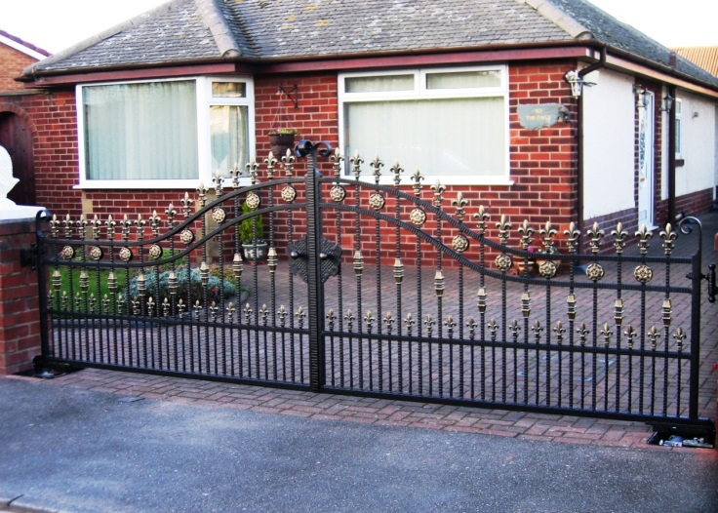 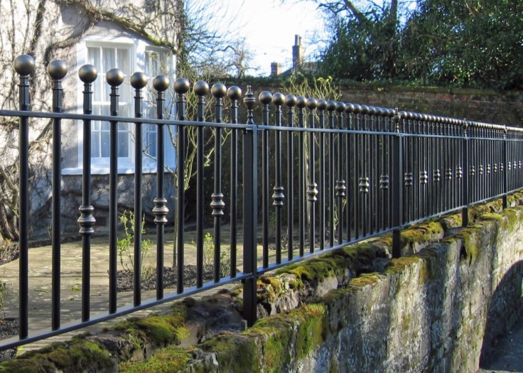

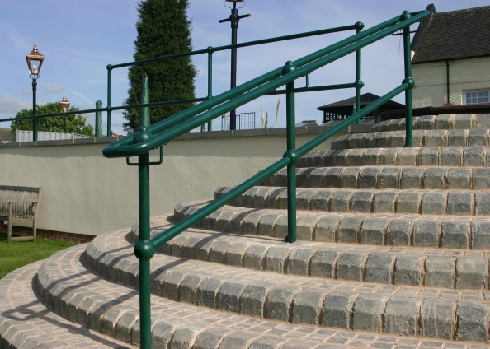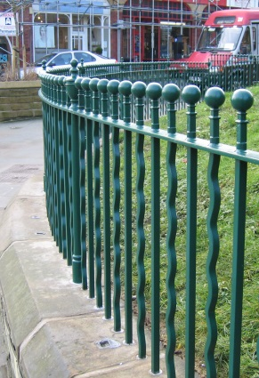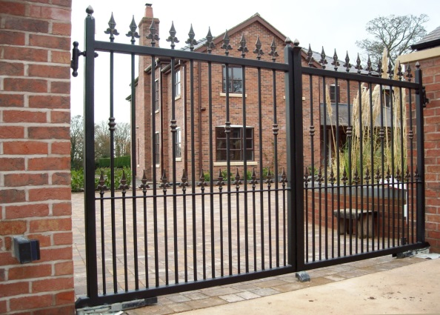

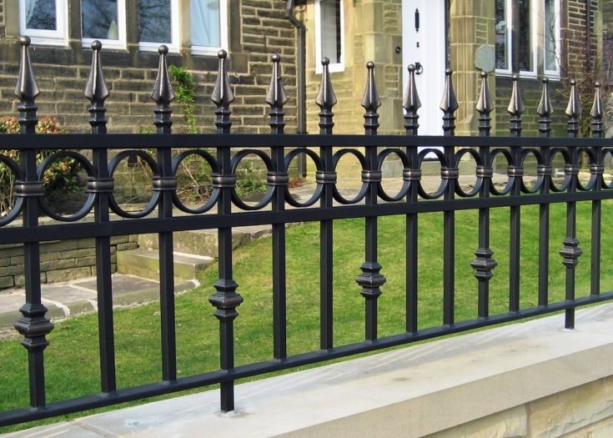 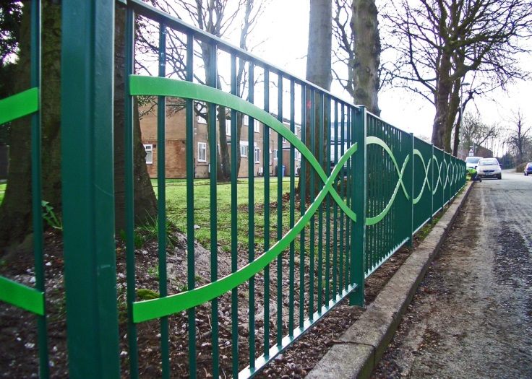

Finally…

We hope this guide has been useful. As always, we try our best to provide a friendly and helpful service, so if you have any further questions please do not hesitate to contact any member of staff who will be pleased to help. If the information isn’t available to hand then we will do our best to find it for you.

Please visit [www.fhbrundle.co.uk](http://www.fhbrundle.co.uk) for a full range of products and our online order service. You can also find a list of all our branches and their contact numbers on our website. You can also e-mail [sales@brundle.com](mailto:sales@brundle.com) for prompt attention.

Brundle Design Studio

F H Brundle has also produced a web app to assist our customers. It can help convert enquiries into sales by enabling you to design ironwork with, or for, your customers. Our *FREE* **Brundle** **Design Studio** can be found on our main website at <http://www.fhbrundle.co.uk/design-app> where you can register.

Brundle Design Studio also contains useful **Calculators** to help with estimating and designing your work, and a shared **Design Library.**

